**Standard Operating Procedures (SOP’s) and Critical Control Points in Crossing trials**

**Hybridization Trials**

Activities carried out during and after hybridization

* Identification of parents
* Design a crossing plan
* Plant your crossing block
* Labell all potential parents
* Carry out hybridization
* Harvest mature fruits
* Process fruits, obtain seeds, label, package and store
* Flowering and flower description
* Flowering time vary depending on location and genotype

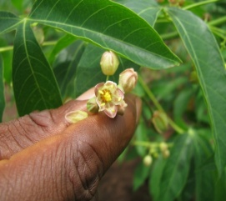 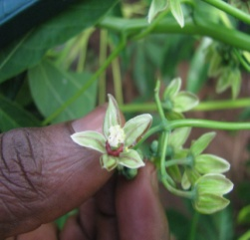 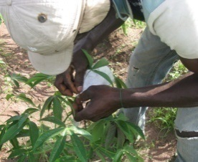 

Male flower Female flower Pollination process Fruit

Figure 1: Hybridization process in cassava

**Materials needed:**

* Pollination bags
* Pencil
* Pollination tags and bags
* Paper tags and bags
* Barcode labels
* Tablet or mobile with barcode scanner (Electronic fieldbook) and power bank
* Field coat with big pockets or apron with pockets, hats and boots
* Seed envelopes
* Pollination bags
* Ribbons (different colours)

Standard Operating Procedures and Critical Control Points for Hybridization

|  |  |  |
| --- | --- | --- |
| **s/n** | **Standard Operating Procedures** | **Critical Control Points** |
| 1 | Identify experienced personnel | Supervisor nominating the right person |
| 2 | Bagging of matured female flower and collection of matured pollen is done in the morning hours (from 8:00 am). | Ensure collected pollen are well labelled and kept in a cool place under shade |
| 3 | Knotting of pollination tags should be done. Enter the details in to crossing tool in cassavabase. | Ensure tags are well knotted |
| 4 | Pollination is carefully done, all needful information is recorded in tablet or mobile device (female genotype x male, number of flowers and date and initials) | Ensure clone names are accurately written, tags well hanged and pollinated flowers well covered to avoid pollen contamination |
| 5 | Remove pollination bags after 72 hours | Ensure all bags are carefully removed timely when due |
| 6 | Score for fruits set after 4weeks of pollination using fieldbook | Ensure fruit set information correspond with the pollination information and confirm where necessary |
| 7 | Always check for mature fruits and bag fruits to avoid shattering | Proper monitoring must be followed at this stage |
| 8 | Seed must be well processed (shelling, sorting counting and packaging) | Use skilled personnel to carry out seeds processing activities |
| 9 | Check for seeds viability before planting particularly when direct seeding is to be done | Conduct floating test for direct seeding, and ensure soil can sustain seed germination |
| 10 | Store seeds in cool dry place | Ensure condition of storage is adequate with periodic checks |