SOP: DETERMINATION OF DRY MATTER CONTENT OF FRESH INTACT CASSAVA ROOT USING HANDHELD NIRS.

Apparatus
Portable vis/nirs device (qualityspec trek: s-10016) from ASD, PANalytical Products, Malvern Panalytical B.V, Lelyweg 1 (7602 EA), PO Box 13, Almelo 7600 AA, Netherlands

Procedure
- Select or choose 3 different suitable sizes of cassava roots (big, medium and small sized). The three different sizes are selected to represent the varying sizes associated with cassava roots.
- Cut the selected cassava roots into three parts horizontally to have proximal, central and distal parts (see image below).

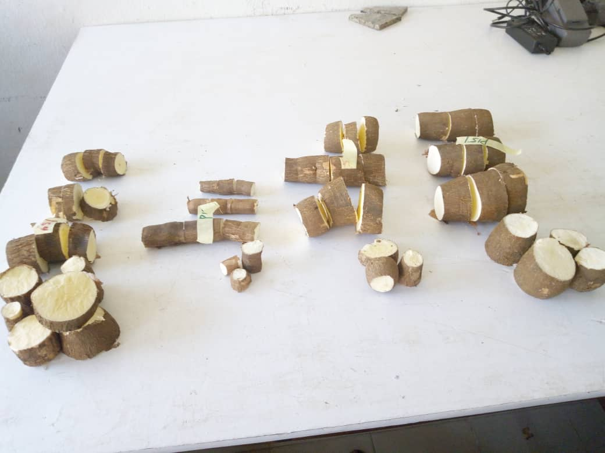
Fig 1. Cut fresh cassava roots prior to spectra capturing

- Place the surfaces of each part of the cut cassava roots against the window of the portable NIRS device and scan. Prior to scanning the samples, spectra of the white reference disc is always taken. This helps check the accuracy of the spectrometer (see image below).

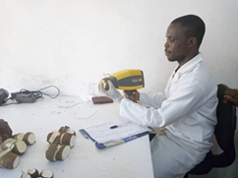
Fig 2. Scanning of the fresh cassava roots

NIRS measurement
Three roots of different sizes (big, medium and small) were randomly chosen for each clone. The roots were cut horizontaly (see fig.1 above) into three regions representing the proximal (P), the middle (M) and the distal (D).
The roots used for the analysis were randomly selected so as to serve as a representative of the whole lot of the samples to be analysed.
- Spectral range & acquisition mode: Absorbance (350 – 2500 nm)
- Spectrometer: QualitySpec Trek: S- 10016

