SOP: DETERMINATION OF DRY MATTER AND AMYLOSE CONTENTS OF WET FUFU MASH AND MILLED GARRI USING HANDHELD NIRS.

Apparatus
Portable vis/nirs device (qualityspec trek: s-10016) from ASD, PANalytical Products, Malvern Panalytical B.V, Lelyweg 1 (7602 EA), PO Box 13, Almelo 7600 AA, Netherlands

Procedure
- Fill 3 different quartz cups with the fufu or milled garri samples (of about 8 – 10g). The three cups are chosen to serve as replicates for the samples during spectra collection.

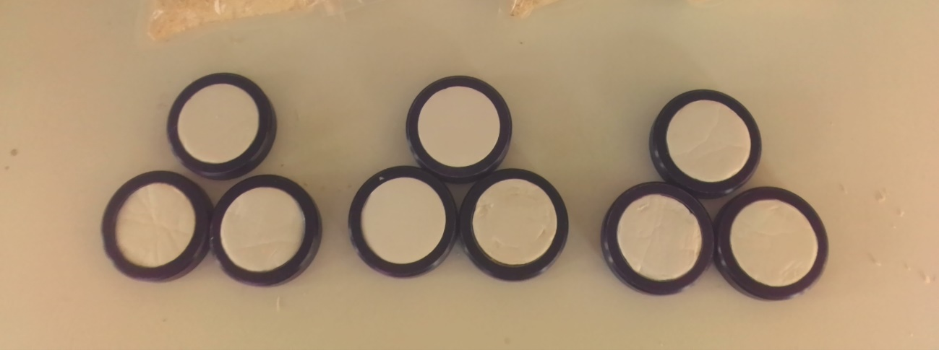
- Cover the already filled sample cups with the white cover (came alongside the portable NIRS device)

Figure 1 Filled sampling quartz cups

- Place the sampling cups against the window of the portable NIRS device and scan. Prior to scanning the samples, spectra of the white reference disc is always taken. This helps check the accuracy of the spectrometer (see image below).
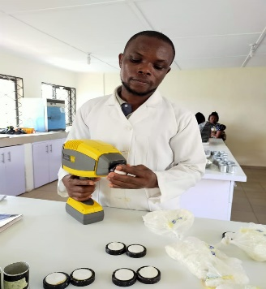

Figure 2 Spectra collection on wet fufu mash/milled garri samples

NIRS MEASUREMENT
Nine spectra were captured on the fufu mashes samples (3 quartz cups captured 3 times on each cup) for each clone. The quantity to be analysed was homogenised and a portion was taken so as to serve as a representative of the whole lot of the samples to be analysed.
- Spectral range & acquisition mode: Absorbance (350 – 2500 nm)
- Spectrometer: QualitySpec Trek: S- 10016

