Standard Operating Procedures for Cassava Breeding Data Management

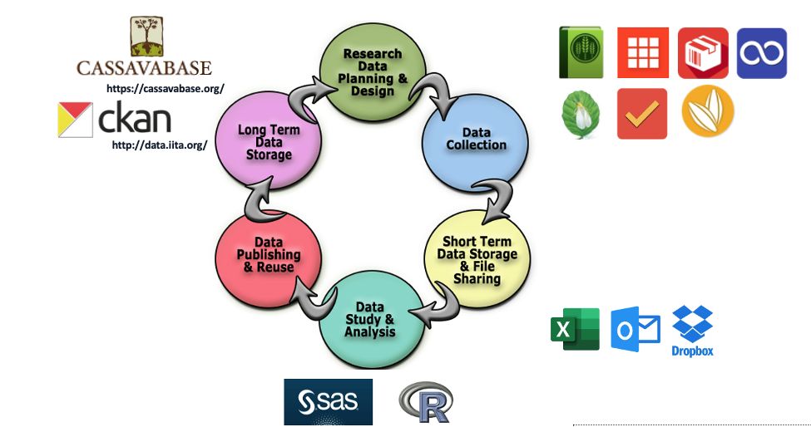

1. Purpose
This document provides standard operating procedures (SOPs) for data collection and management in cassava breeding. Phenotyping, crossing, NIRS quality assessment, and DNA sample management are among the tasks completed.

2. Material & tools required
- Tablets or Mobiles
- Laser jet Printer
- Barcode labels
VLX1081SWH ( 1” x 8 ½” Laser slip on tag) : Regular Labels for field use
CLPS1020SWH ( 2 x 1 laser label , 40 labels per sheet ) : Sticky labels for lab and field use

PhenoApp tools
- Fieldbook - This is used for collecting field evaluation data
- Coordinate - This is used for Genotyping sample tracking
- Intercross - This is used for collecting Crossing information
- Whitefly count -This is used for counting whitefly images on cassava leaf
- Inventory - This is used for collecting sample weights
Cassavabase is an open source database that provides a digital ecosystem to manage breeding programs, including phenotypic and genotypic data, and analysis tools to assist in advancing the breeding cycle.

3. Steps involved in Phenotyping data management:

Step1: Plan Experimental Design
Experimental type | Design | Number of plants per plot | No of reps | No of locations
Seedling Nursery | Augmented | 1 | 1 | 1
CE | Augmented | 5 | 1 | 1
PYT | RCBD | 5 or 10 | 2 | 2
AYT | RCBD | 20 or 28 | 3 | 4
UYT | Alpha Lattice | 42 | 3 | 6
NCRP | Alpha Lattice | 35 | 3 | 10

Step2: Create new trial in Cassavabase
Log into Cassavabase to add a new trial. The typical steps followed are:
- Navigate to Manage and select field trials.
- Begin the “Design New Trial” workflow by clicking on Design New Trial.
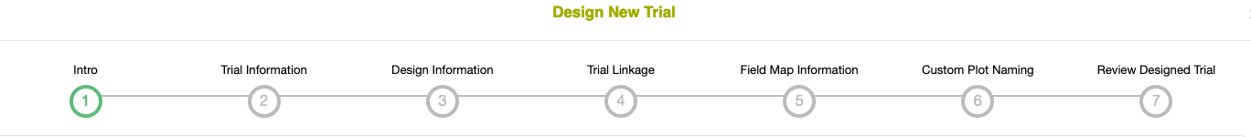
- Enter all relevant meta data in “Trial Information” (e.g. trial name, location, plot and field dimensions, trial type, design type, description)
- Enter “Design Information” (e.g. list of genotypes in trial (list should already be defined in Cassavabase).
- Enter “Trial Linkage” information if applicable.
- Enter “Field Map Information” (here you can specify how the row and column numbers will be generated for the plots in the trial)
- Custom Plot Naming (optional)
- Review Designed Trial
- Save new trial in the database.

Step3. Print field labels
Designing your field label using Cassavabase label designer
- Navigate to “Manage” and select “Label designer”
- Select a data source and a data level then click Next
- Select page format and a Label format, you may retrieve these settings from a saved design or you can start a new design.
- Design your label by selecting the type of barcode which should be 2D Barcode (QR code), also select the field and size then click add to generate your new label element in the draw area
- Change the type to Text (PDF) to add other fields
- The exported file will contain amongst other fields the plot name, pedigree, accession name, plot number, block number and replication number
- Edit additional settings and Download pdf
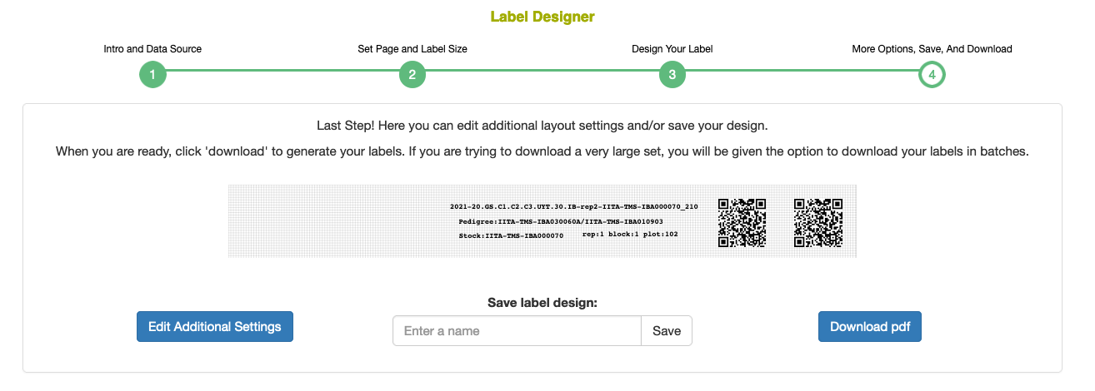

- Always open the downloaded pdf in Adobe Acrobat reader and check if the labels look fine
- Press the Ctrl and P buttons (Windows) or Command (⌘) and P button (Mac) on your keyboard at the same time to print
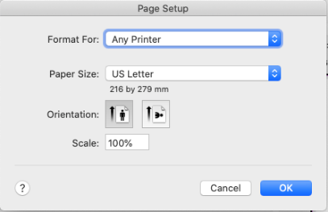
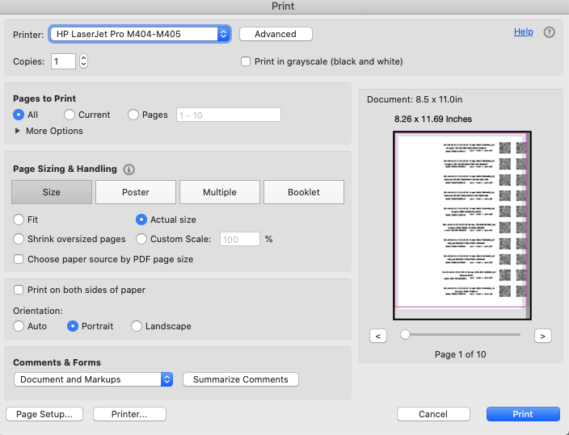
- You have to always select actual size in the “Page sizing & Handling” options and under “Page Setup” select the page you have chosen in step2 while designing the label
Note: always try to print the first page and see if labels are printed correctly, after confirmation you can go ahead and print all the pages, if not adjust your design and try again.

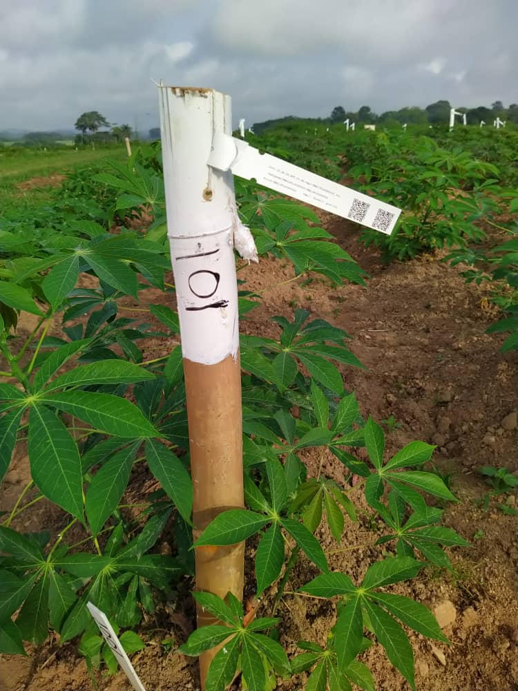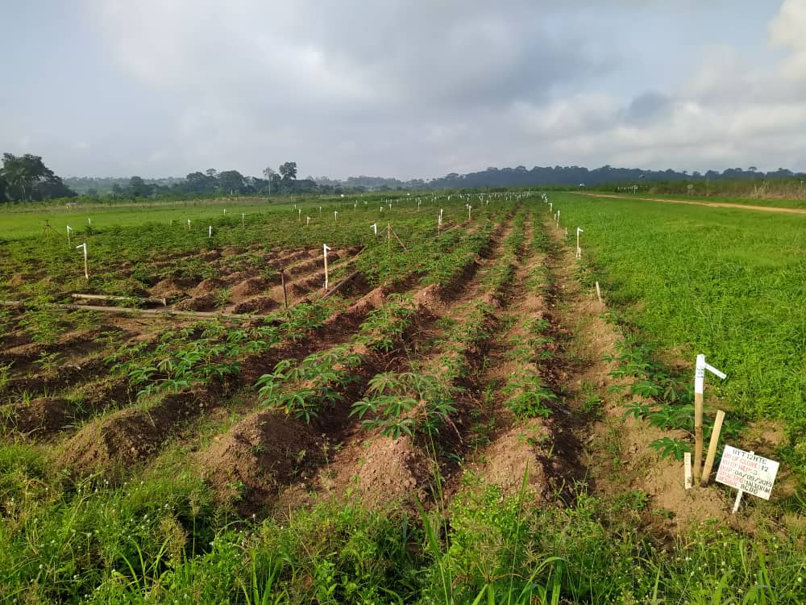
Tagging barcode labels in the field

Step 4: Field data collection using the Field Book App
We require two input files for data collection
- Field layout
- Trait file
We can generate them on cassavabase

4.1 Creating a field layout file based on the design of the field trial
- Navigate to “Manage”, click “Field Trials” and select the desired trial to open the “trial detail page” to achieve that, double click the desired trial.
- Scroll down the page and expand the Upload Data Files section.
- On the Android Field Book Layout row click on “Create Field Book” to generate the layout file.
- A new dialogue box will appear with the trial details and options to select spreadsheet format and desired data level.
- Click Submit and click on the link popping up to download layout file.

4.2 Creating a trait file from the list of traits
- Navigate to menu item Search Traits to open the “trait search page”
- Search desired traits by ID, name or description
- Select desired trait in the results.
- Add selected results to a trait list (This could be an existing trait list or a new trait list. It is possible to create a new trait list on the fly).
- Navigate to menu item “Manage” then “Field Book App”.
- Find the heading “Trait Files” and click on new to create your file.
- A new dialogue box will open. Select the traits list that you created from the drop-down list.
- Check the box titled “Include Notes Trait” if you would also like to record and upload general plot notes in the field.
- Type in an appropriate file name and click on Submit to download your traits file.

4.3. Downloading the field layout file and trait file from the database to your computer
Your field layout and trait files are now downloaded to your computer. You can copy them onto your tablet or copy them to your team’s cloud storage like dropbox or OneDrive
To Copy the field layout file and trait file to the tablet with the Field Book App
- Connect your android tablet to your computer using via a USB cable
- Copy the field layout file into the field Book>field_import folder in the tablet
- Copy the traits list files into the field Book>trait folder
- Open the field Book app to import the new field layout and Traits files.
Note: You can also import the field layout and trait files directly from your team’s dropbox or OneDrive cloud storage.

4.4. Collecting phenotypes
An important aspect when collecting phenotypic data is to use barcode labels to avoid errors. You can use different trait files for various stages of evaluation, e.g. 3MAP, 6MAP, Harvest etc. The ranges specified for each trait provides validation for quality data collection Note:
- Never use zero as missing values
- Always try to export or save your data collected on every day after evaluation
- Regular back-ups should be taken on the computers, we can even use cloud server for this

4.5. Exporting phenotypes from Field Book App to your computer
- Connect your android tablet to your computer using via a USB cable
- Tap “Export” under settings to export data collected
- You can either export in database format, or table format. Table format is in the form of spreadsheet.
- The file name can be edited under “Filename” to suit the needed names to be given to a trial based on its type, other information about the trial.
- Access the “field_export” sub-folder in the “Fieldbook” folder
- Data exported in table format can be accessed in spreadsheet format (.xls) on the PC.
- All trial’s data collected are located in the “field_export” sub-folder in the “fieldbook” folder.

Step 5: Data Curation
It is important to curate the data by checking it for inconsistencies and correcting it if necessary. We use some in-house R scripts to perform this task. In the future, data curation will be made possible within Cassavabase so that the partial uploads would be recommended. For now, however, the data can best be merged on your computer so that it can be curated and then be uploaded to Cassavabase. In particular, the following are the data curation steps followed
- Meta data – trial name, source, no of clones, reps, plot size, spacing, DOP, location, experiment design, person(s) responsible
- Check the layout file heading they should include: plot_name, accession, plot, block_number, is_a_control, rep_number, row_number, col_number
- Check the trait names headings
- Validating the layout content
  - plot_name – it should be combination of year+trialname+rep+accession+plot
  - accession – It should be validated through cassavabase using a list
  - plot number – use 101,102... For AYT, PYT, UYT trials 1001,1002... for SN and CE
  - source – it should be available trail name(s) from cassavabase
  - rep – check for equal no of accession in each rep, check for clone names in each rep
- Validating the trait values
  - Check the file for special characters and remove – NA, “.”, dead, “?”
  - Check for the out-of-range values – each trait should have min and max values

Step 6: Upload collected data to Cassavabase.
A commitment of Cassava breeding Data Management team is to upload all field trial data to Cassavabase Immediately after data curation.

Step 7: Data analysis
The trial data can be downloaded and analyzed. Statistical tools such as R can be used to analyze trial data. Cassavabase also has certain standard analyses available. The following Data analysis are normally performed on trials after each evaluation
- Mean of each accession
- Overall mean for each trait
- Min and Max value of each trait
- Standard deviation of each trait
- Standard error of each trait
- Distribution and outlier detection of each trait
- Coefficient of variance of each trait
- Probability of the F statistic: Pr > F

Annex A. Cassava naming conventions

1. Name structure
Trials, plots, accessions, cross experiments, crossings, and families need a standard naming structure. These names are constructed by concatenating the letters, numbers and symbols listed in the first column of the following table in the order described by the numbers in the corresponding column for each item.

2. Abbreviations

2.1. Institution code
IITA - International Institute of Tropical Agriculture

2.2. Species code
TMS - Tropical Manihot Species
TME - Tropical Manihot esculenta, a prefix for all IITA landrace accessions

2.3 Trial Stages
SN | : | Seedling nursery
CET | : | Clonal Evaluation
PYT | : | Preliminary yield trial
AYT | : | Advanced yield trial
UYT | : | Uniform yield Trial
NCRP | : | Nationally Coordinated Research Programme
OFT | : | On-Farm trial
DCT | : | Demand creation Trial

2.4 Locations
IBA | : | Ibadan |  | ABU | : | Abuja
IKN | : | Ikenne |  | ZAR | : | Zaria
AGO | : | Ago-Owu |  | MOK | : | Mokwa
UBJ | : | Ubiaja |  | KAN | : | Kano
ONN | : | Onne |  | MM | : | Malam Madori

3. Examples

3.1. Trial name example
21pyt48highTCIB  21 - Year of trial establishment  pyt - Trial stage  48 - No. of Genotypes used  highTC - Purpose of the trial  IB – Location | 20.GS.C1.C2.C3.UYT.30.IB  20 - Year of trial establishment  GS - Genomic Selection  C1.C2.C3 - Cycles  UYT - Trial stage  30 - No. of Genotypes used  IB - Location

3.2. Plot name example
2021-20.GS.C1.C2.C3.UYT.30.IB-rep1-TMS17F1377P0077_103

2021 - Year of Harvest
20.GS.C1.C2.C3.UYT.30.IB - Trial name
rep1 - Replication
TMS17F1377P0077 - Accession or Clone name
103 - Plot number

3.3. Accession name example
IITA-TMS-IBA210134  IITA - Institute name  TMS - Species name  IBA - Location name  21 - Year  0134 - Four-digit Identifier | TMS17F1377P0077  TMS – Species name  17 - Year  F1377 - Family four-digit identifier  P0077 - Progeny four-digit identifier

